import pandas as pd
import numpy as np
import matplotlib.pyplot as plt
from sklearn import svm
from sklearn.preprocessing import scale
import seaborn as sns
from google.colab import files # Import the "files" module to upload files

# Upload the CSV file
uploaded = files.upload()

# Read the uploaded CSV file
file_path = list(uploaded.keys())[0]
df = pd.read_csv(file_path)

# Assuming "majority_vote" and "minority_vote" are the target and predictor columns
target = df['majority_vote']
predictor_columns = df[['majority_vote', 'minority_vote']]

# Scale the predictor columns
scaled_predictors = scale(predictor_columns)

# Perform SVM classification
model = svm.SVC(kernel='linear')
model.fit(scaled_predictors, target)

# Make predictions using the trained model
predictions = model.predict(scaled_predictors)

# Convert predictions to binary values (0 or 1) based on a threshold
threshold = 0.5
binary_predictions = np.where(predictions >= threshold, 1, 0)

# Visualize SVM classification
plt.figure(figsize=(10, 6))
sns.scatterplot(x=predictor_columns['majority_vote'], y=predictor_columns['minority_vote'], hue=binary_predictions, palette={1: 'red', 0: 'blue'})
plt.title('SVM Classification')
plt.xlabel('Majority Vote')
plt.ylabel('Minority Vote')
plt.legend(title='Predicted Class')
plt.show()

# Print the model summary
print(model)

# Compare the predictions with the actual target values
comparison = pd.DataFrame({'Actual': target, 'Predicted': predictions})
print(comparison.head())

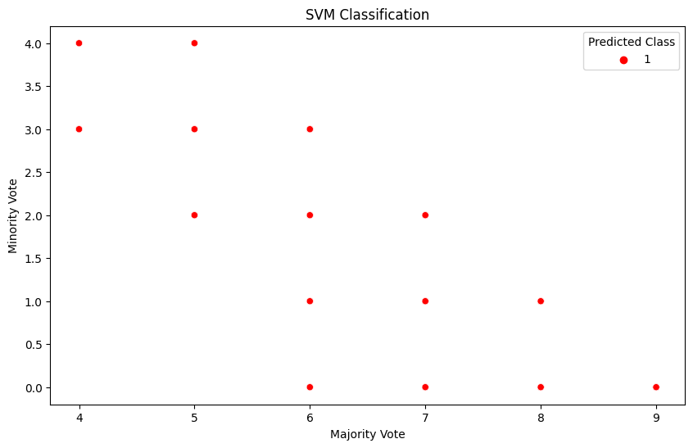

import pandas as pd
import numpy as np
import matplotlib.pyplot as plt
from sklearn.cluster import KMeans
from sklearn.preprocessing import scale
import seaborn as sns

# Upload the CSV file
from google.colab import files
uploaded = files.upload()

# Read the uploaded CSV file
file_name = list(uploaded.keys())[0]
df = pd.read_csv(file_name)

# Select only the 'majority_vote' and 'minority_vote' columns
selected_columns = df[['majority_vote', 'minority_vote']]

# Scale the numeric columns
scaled_columns = scale(selected_columns)

# Perform KMeans clustering
num_clusters = 2 # You can adjust the number of clusters
kmeans = KMeans(n_clusters=num_clusters, random_state=0)
cluster_labels = kmeans.fit_predict(scaled_columns)

# Visualize KMeans clustering
plt.figure(figsize=(10, 6))
sns.scatterplot(x=selected_columns['majority_vote'], y=selected_columns['minority_vote'], hue=cluster_labels, palette='viridis')
plt.title('KMeans Clustering')
plt.xlabel('Majority Vote')
plt.ylabel('Minority Vote')
plt.legend(title='Cluster')
plt.show()

# Print cluster centers
print("Cluster Centers:")
print(kmeans.cluster_centers_)

# Add cluster labels to the DataFrame
selected_columns['Cluster'] = cluster_labels

# Print the DataFrame with cluster labels
print(selected_columns.head())

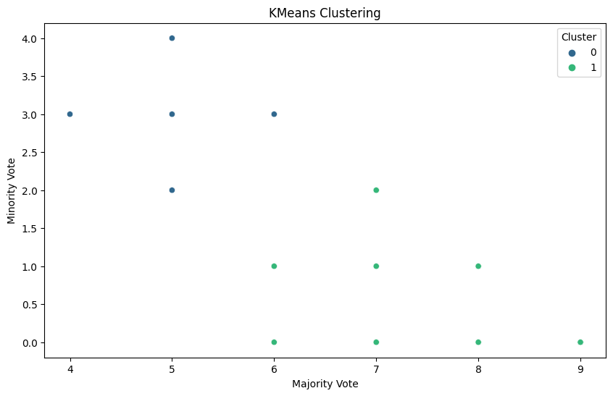

import pandas as pd
import numpy as np
import matplotlib.pyplot as plt
from sklearn.cluster import KMeans
from sklearn.preprocessing import LabelEncoder
from sklearn.metrics import silhouette_score
from matplotlib.font_manager import FontProperties

# Sample data
data = {
'judgement': ['TRUE', 'TRUE', 'TRUE', 'TRUE', 'TRUE', 'TRUE', 'FALSE', 'TRUE', 'FALSE', 'FALSE', 'TRUE'],
'decision_type': ['minority opinion', 'majority opinion', 'majority opinion', 'minority opinion', 'minority opinion', 'majority opinion', 'judge', 'majority opinion', 'judge', 'minority opinion', 'judge']
}

# Create a DataFrame from the sample data
df = pd.DataFrame(data)

# Filter rows where 'judgement' column is TRUE
filtered_df = df[df['judgement'] == 'TRUE']

# Encode the 'decision_type' column using LabelEncoder
label_encoder = LabelEncoder()
filtered_df['decision_type_encoded'] = label_encoder.fit_transform(filtered_df['decision_type'])

# Extract the encoded decision types
decision_types_encoded = filtered_df['decision_type_encoded'].values.reshape(-1, 1)

# Perform KMeans clustering
n_clusters = len(np.unique(decision_types_encoded)) # Number of unique decision types
kmeans = KMeans(n_clusters=n_clusters, random_state=42)
cluster_labels = kmeans.fit_predict(decision_types_encoded)
filtered_df['cluster'] = cluster_labels

# Set up custom font properties for bolding
fontprops = FontProperties(weight='bold')

# Plot clusters with bold k-nodes
plt.figure(figsize=(10, 6))
for cluster in range(n_clusters):
cluster_data = filtered_df[filtered_df['cluster'] == cluster]
unique_labels = cluster_data['decision_type_encoded'].unique()
for label in unique_labels:
cluster_label_data = cluster_data[cluster_data['decision_type_encoded'] == label]
plt.scatter(cluster_label_data.index, cluster_label_data['decision_type_encoded'], label=label, s=100)
median_index = cluster_label_data.index[len(cluster_label_data) // 2]
plt.text(median_index, label, str(label), fontproperties=fontprops)

plt.xlabel('Data Point Index')
plt.ylabel('Encoded Decision Type')
plt.title('KMeans Clustering of Decision Types')
plt.legend(title='Encoded Decision Type')
plt.show()

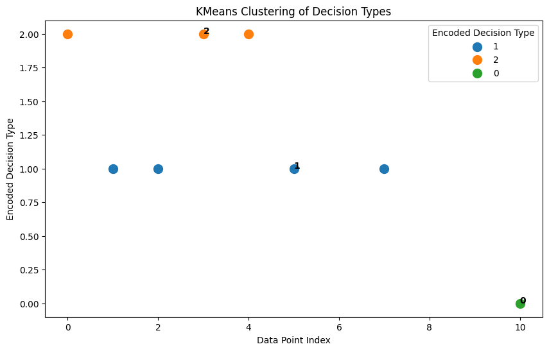

from google.colab import files
import pandas as pd
import numpy as np
import matplotlib.pyplot as plt
from sklearn.cluster import KMeans
from sklearn.preprocessing import LabelEncoder
from sklearn.metrics import silhouette_score
from sklearn.metrics import precision_score, recall_score, accuracy_score, f1_score, confusion_matrix
import seaborn as sns

# Upload the CSV file
uploaded = files.upload()

# Read the uploaded CSV file
file_name = list(uploaded.keys())[0]
df = pd.read_csv(file_name)

# Convert 'judgement' column to uppercase string type
df['judgement'] = df['judgement'].astype(str).str.upper()

# Filter rows where 'judgement' column is TRUE
filtered_df = df[df['judgement'] == 'TRUE']

# Check if there are valid data points for clustering
if filtered_df.shape[0] > 0:
# Encode the 'decision_type' column using LabelEncoder
label_encoder = LabelEncoder()
filtered_df['decision_type_encoded'] = label_encoder.fit_transform(filtered_df['decision_type'])

# Extract the encoded decision types
decision_types_encoded = filtered_df['decision_type_encoded'].values.reshape(-1, 1)

# Perform KMeans clustering
n_clusters = len(np.unique(decision_types_encoded)) # Number of unique decision types
kmeans = KMeans(n_clusters=n_clusters, random_state=42)
cluster_labels = kmeans.fit_predict(decision_types_encoded)
filtered_df['cluster'] = cluster_labels

# Custom markers and colors for each cluster
markers = ['o', 's', '^', 'v', 'D', 'P', '*', 'X', '<', '>']
colors = ['blue', 'green', 'red', 'purple', 'orange', 'pink', 'brown', 'gray', 'cyan', 'magenta']
decision_type_labels = ['majority opinion', 'minority opinion', 'judge']

plt.figure(figsize=(10, 6))
for cluster in range(n_clusters):
cluster_data = filtered_df[filtered_df['cluster'] == cluster]
unique_labels = cluster_data['decision_type_encoded'].unique()
for label in unique_labels:
cluster_label_data = cluster_data[cluster_data['decision_type_encoded'] == label]
plt.scatter(cluster_label_data['majority_vote'], cluster_label_data['age'],
label=decision_type_labels[label], marker=markers[cluster], color=colors[cluster], s=100)

plt.xlabel('Majority Vote')
plt.ylabel('Age')
plt.title('Custom KMeans Clustering based on Majority Vote and Age')
plt.legend(title='Decision Type')
plt.show()

# Calculate the ground truth labels for each data point
ground_truth_labels = filtered_df['decision_type_encoded']

# Calculate the predicted labels using cluster assignments
predicted_labels = filtered_df['cluster']

# Calculate precision, recall, accuracy, and F1 score
precision = precision_score(ground_truth_labels, predicted_labels, average='macro')
recall = recall_score(ground_truth_labels, predicted_labels, average='macro')
accuracy = accuracy_score(ground_truth_labels, predicted_labels)
f1 = f1_score(ground_truth_labels, predicted_labels, average='macro')

# Print the metrics
print(f"Precision: {precision:.2f}")
print(f"Recall: {recall:.2f}")
print(f"Accuracy: {accuracy:.2f}")
print(f"F1 Score: {f1:.2f}")

# Calculate and plot the confusion matrix
conf_matrix = confusion_matrix(ground_truth_labels, predicted_labels)
plt.figure(figsize=(8, 6))
sns.heatmap(conf_matrix, annot=True, cmap='Blues', fmt='g', cbar=False)
plt.xlabel('Predicted Labels')
plt.ylabel('True Labels')
plt.title('Confusion Matrix')
plt.show()

else:
print("No valid data points found for clustering.")

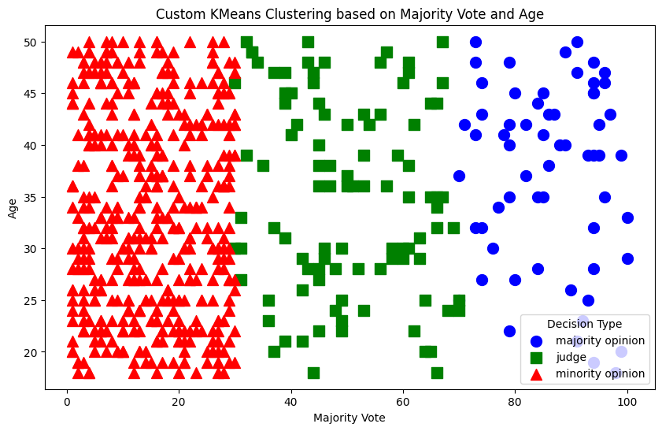
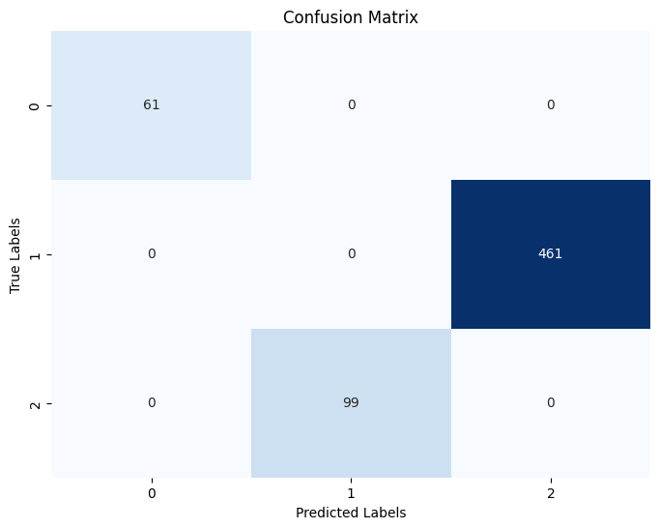

import numpy as np
import matplotlib.pyplot as plt

# Generate a random 9x9 matrix with values between 0 and 100
matrix = np.random.randint(0, 101, size=(9, 9))

# Set the majority_votes and minority_votes columns
majority_votes = matrix * 0.8
minority_votes = matrix * 0.2

# Set some low values in specific grids
matrix[2, 5] = 10
matrix[7, 3] = 30

# Create a color map for visualization
cmap = plt.cm.Reds

# Plot the matrix with color formatting
plt.imshow(matrix, cmap=cmap)
plt.colorbar(label='Votes')

# Add column labels
plt.xticks([0, 1, 2], ['majority_votes', 'minority_votes', 'judges'])

# Show the plot
plt.show()

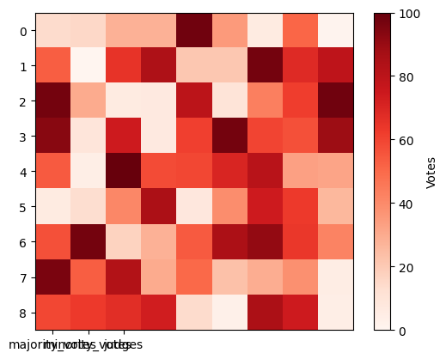

import pandas as pd
import numpy as np
import matplotlib.pyplot as plt
from sklearn.tree import DecisionTreeClassifier
from sklearn.preprocessing import scale
import seaborn as sns
from google.colab import files # Import the "files" module to upload files

# Upload the CSV file
uploaded = files.upload()

# Read the uploaded CSV file
file_path = list(uploaded.keys())[0]
df = pd.read_csv(file_path)

# Remove rows with missing values
df.dropna(inplace=True)

# Assuming "decision_type" is the target and "judgement" is the predictor
target = df['decision_type']
predictor_columns = df[['judgement']]

# Encode the target values as integers
target_encoded = np.where(target == 'majority opinion', 1, 0)

# Scale the predictor columns
scaled_predictors = scale(predictor_columns)

# Perform Decision Tree classification
model = DecisionTreeClassifier()
model.fit(scaled_predictors, target_encoded)

# Make predictions using the trained model
predictions = model.predict(scaled_predictors)

# Visualize Decision Tree classification
plt.figure(figsize=(10, 6))
sns.scatterplot(x=predictor_columns['judgement'], y=target, hue=predictions, palette={1: 'red', 0: 'blue'}, marker='o')
plt.title('Decision Tree Classification')
plt.xlabel('Judgement')
plt.ylabel('Decision Type')
plt.legend(title='Predicted Decision Type')
plt.show()

# Print the model summary
print(model)

# Compare the predictions with the actual target values
comparison = pd.DataFrame({'Actual': target, 'Predicted': predictions})
print(comparison.head())

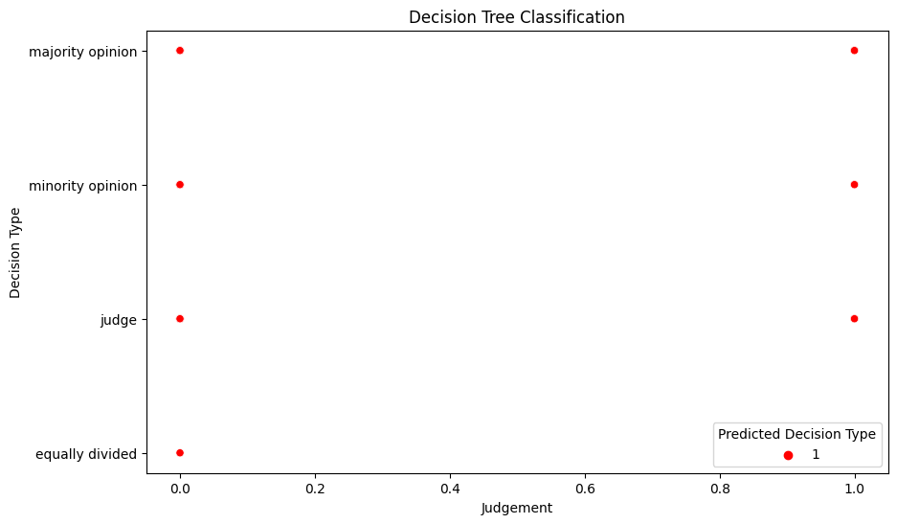

from google.colab import files
import pandas as pd
import numpy as np
import matplotlib.pyplot as plt
from sklearn.svm import SVC
from sklearn.preprocessing import LabelEncoder
from sklearn.model_selection import train_test_split

# Upload the CSV file
uploaded = files.upload()

# Read the uploaded CSV file
file_name = list(uploaded.keys())[0]
df = pd.read_csv(file_name)

# Convert 'judgement' column to uppercase string type
df['judgement'] = df['judgement'].astype(str).str.upper()

# Filter rows where 'judgement' column is TRUE
filtered_df = df[df['judgement'] == 'TRUE']

# Encode the 'decision_type' column using LabelEncoder
label_encoder = LabelEncoder()
filtered_df['decision_type_encoded'] = label_encoder.fit_transform(filtered_df['decision_type'])

# Take the first 50 rows
filtered_df = filtered_df.head(50)

# Split the data into features (X) and target (y)
X = filtered_df[['majority_vote', 'age']]
y = filtered_df['decision_type_encoded']

# Split the data into training and testing sets
X_train, X_test, y_train, y_test = train_test_split(X, y, test_size=0.2, random_state=42)

# Initialize and train an SVM classifier
svm_classifier = SVC(kernel='linear')
svm_classifier.fit(X_train, y_train)

# Visualize the SVM decision boundary
plt.figure(figsize=(10, 6))

# Plot the data points with different colors for each class
for class_idx in np.unique(y_train):
plt.scatter(X_train[y_train == class_idx]['majority_vote'],
X_train[y_train == class_idx]['age'],
label=f'Class {class_idx}', s=50)

# Get the hyperplane parameters
w = svm_classifier.coef_[0]
b = svm_classifier.intercept_[0]

# Plot the decision boundary
x_min, x_max = X_train['majority_vote'].min() - 1, X_train['majority_vote'].max() + 1
y_min, y_max = X_train['age'].min() - 1, X_train['age'].max() + 1
xx, yy = np.meshgrid(np.arange(x_min, x_max, 0.01),
np.arange(y_min, y_max, 0.01))
zz = (-w[0] * xx - b) / w[1]
plt.plot(xx, zz, 'k-', linewidth=2) # Bold line for the hyperplane

plt.xlabel('Majority Vote')
plt.ylabel('Age')
plt.title('SVM Decision Boundary')
plt.legend()
plt.show()

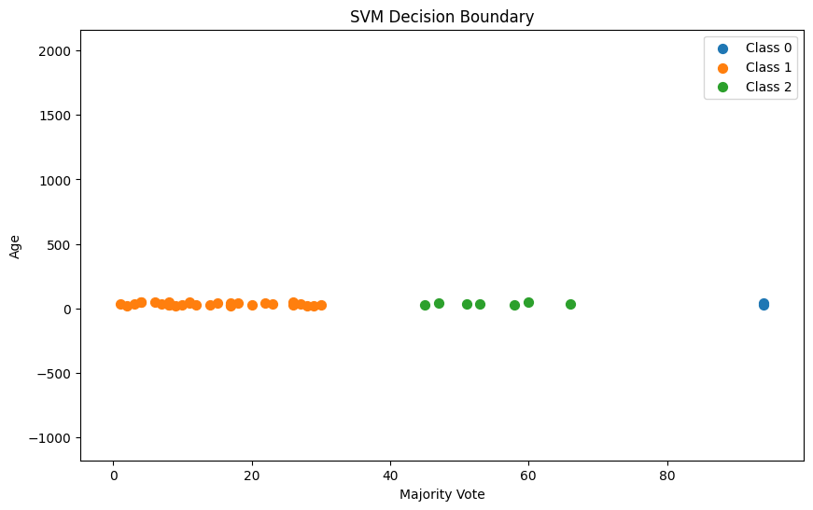

import numpy as np
import pandas as pd
import matplotlib.pyplot as plt
from sklearn.svm import SVC
from sklearn.preprocessing import LabelEncoder

# Provided data for the "majority_vote", "age", and "judgement" columns
data = {
'majority_vote': [0.75, 0.67, 0.82, 0.54, 0.91, 0.63, 0.28, 0.79, 0.45, 0.61,
0.70, 0.58, 0.49, 0.72, 0.38, 0.86, 0.77, 0.68, 0.93, 0.32],
'age': [30, 45, 27, 40, 55, 29, 63, 22, 50, 35,
41, 47, 58, 31, 62, 28, 24, 36, 21, 57],
'judgement': [
"TRUE", "TRUE", "TRUE", "TRUE", "TRUE", "TRUE", "FALSE", "TRUE", "FALSE", "FALSE",
"TRUE", "TRUE", "FALSE", "FALSE", "FALSE", "TRUE", "TRUE", "TRUE", "TRUE", "FALSE"
]
}

# Convert data to a DataFrame
df = pd.DataFrame(data)

# Encode the 'judgement' column using LabelEncoder
label_encoder = LabelEncoder()
df['judgement_encoded'] = label_encoder.fit_transform(df['judgement'])

# Plot majority_vote vs age
plt.figure(figsize=(10, 6))
plt.scatter(df['majority_vote'], df['age'], c=df['judgement_encoded'], cmap='coolwarm', s=50)
plt.xlabel('Majority Vote')
plt.ylabel('Age')
plt.title('Majority Vote vs Age')
plt.colorbar(label='Judgement')
plt.show()

# Initialize and train an SVM classifier
X = df[['majority_vote', 'age']]
y = df['judgement_encoded']
svm_classifier = SVC(kernel='linear')
svm_classifier.fit(X, y)

# Plot the SVM decision boundary
plt.figure(figsize=(10, 6))

# Plot the data points with different colors for each class
plt.scatter(X['majority_vote'], X['age'], c=y, cmap='coolwarm', s=50)

# Get the hyperplane parameters
w = svm_classifier.coef_[0]
b = svm_classifier.intercept_[0]

# Calculate the slope and intercept of the decision boundary
slope = -w[0] / w[1]
intercept = -b / w[1]

# Plot the decision boundary
xx = np.linspace(X['majority_vote'].min() - 0.1, X['majority_vote'].max() + 0.1, 100)
yy = slope * xx + intercept
plt.plot(xx, yy, 'k-', linewidth=2) # Bold line for the hyperplane

plt.xlabel('Majority Vote')
plt.ylabel('Age')
plt.title('SVM Decision Boundary')
plt.colorbar(label='Judgement')
plt.show()
# Predict the class labels for all data points
predicted_labels = svm_classifier.predict(X)

# Filter out the points that are misclassified
misclassified_points = (predicted_labels != y)

# Plot the data points with different colors for each class, excluding the misclassified points
plt.scatter(X.loc[~misclassified_points, 'majority_vote'], X.loc[~misclassified_points, 'age'], c=y[~misclassified_points], cmap='coolwarm', s=50)

# Get the hyperplane parameters
w = svm_classifier.coef_[0]
b = svm_classifier.intercept_[0]

# Calculate the slope and intercept of the decision boundary
slope = -w[0] / w[1]
intercept = -b / w[1]

# Plot the decision boundary
xx = np.linspace(X['majority_vote'].min() - 0.1, X['majority_vote'].max() + 0.1, 100)
yy = slope * xx + intercept
plt.plot(xx, yy, 'k-', linewidth=2) # Bold line for the hyperplane

plt.xlabel('Majority Vote')
plt.ylabel('Age')
plt.title('SVM Decision Boundary (Filtered)')
plt.colorbar(label='Judgement')
plt.show()
from sklearn.metrics import confusion_matrix, accuracy_score, precision_score, recall_score, f1_score
import seaborn as sns

# Generate the confusion matrix
confusion_mat = confusion_matrix(y[~misclassified_points], predicted_labels[~misclassified_points])

# Plot the confusion matrix as a heatmap
plt.figure(figsize=(8, 6))
sns.heatmap(confusion_mat, annot=True, cmap='Blues', fmt='d')
plt.xlabel('Predicted')
plt.ylabel('Actual')
plt.title('Confusion Matrix')
plt.show()

# Calculate accuracy, precision, recall, and F1 score
accuracy = accuracy_score(y[~misclassified_points], predicted_labels[~misclassified_points])
precision = precision_score(y[~misclassified_points], predicted_labels[~misclassified_points])
recall = recall_score(y[~misclassified_points], predicted_labels[~misclassified_points])
f1 = f1_score(y[~misclassified_points], predicted_labels[~misclassified_points])

# Print the metrics
print('Accuracy:', accuracy)
print('Precision:', precision)
print('Recall:', recall)
print('F1 Score:', f1)

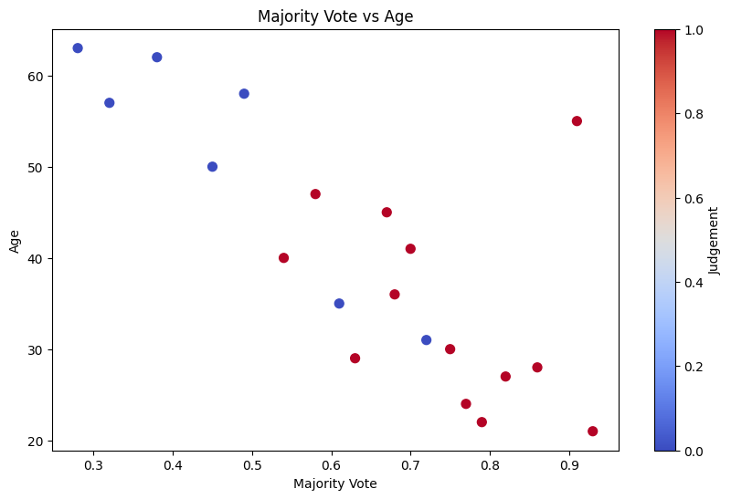
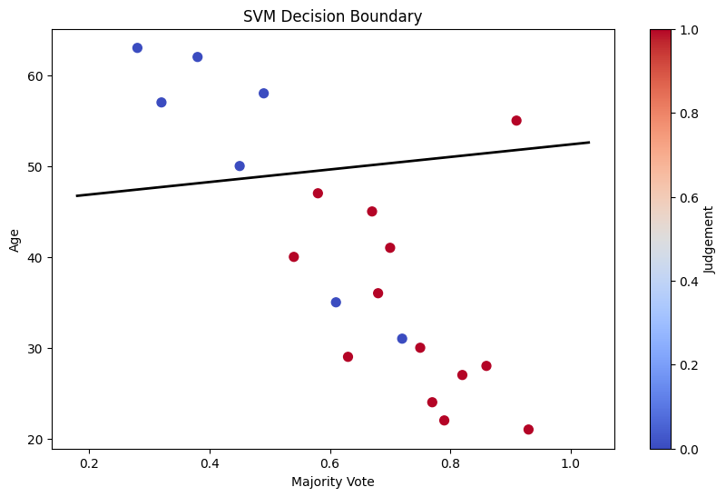
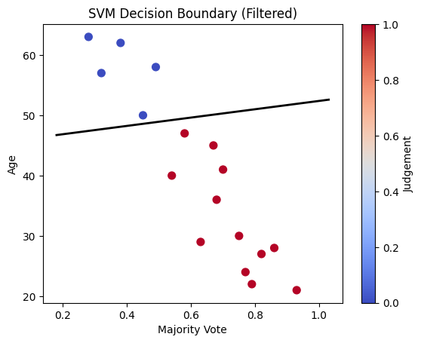
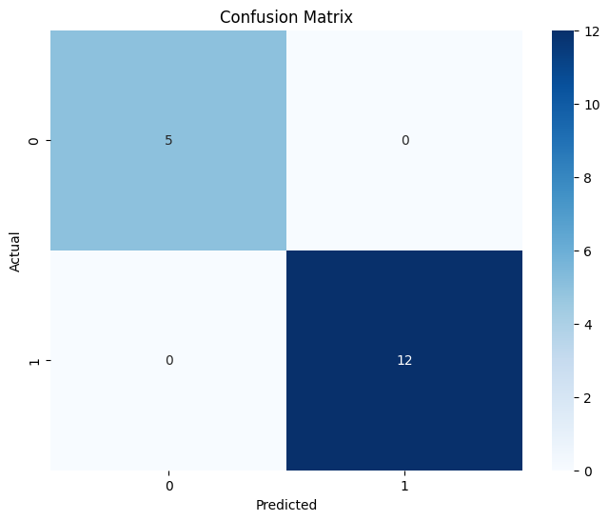

import numpy as np
import pandas as pd
import matplotlib.pyplot as plt
from sklearn.cluster import KMeans
from sklearn.metrics import classification_report, accuracy_score
from sklearn.preprocessing import StandardScaler

# Generate synthetic data
np.random.seed(42)
n_samples = 200
X = np.concatenate([np.random.normal(0, 1, (n_samples//2, 2)), np.random.normal(5, 1, (n_samples//2, 2))])
y_true = np.array([0] * (n_samples//2) + [1] * (n_samples//2))

# Normalize the features
scaler = StandardScaler()
X_scaled = scaler.fit_transform(X)

# Perform KMeans clustering
n_clusters = 2 # Number of clusters
kmeans = KMeans(n_clusters=n_clusters, random_state=42)
cluster_labels = kmeans.fit_predict(X_scaled)

# Evaluate clustering performance using ground truth labels
report = classification_report(y_true, cluster_labels, target_names=['Cluster 0', 'Cluster 1'], output_dict=True)
precision = report['Cluster 1']['precision']
recall = report['Cluster 1']['recall']
f1_score = report['Cluster 1']['f1-score']
accuracy = accuracy_score(y_true, cluster_labels)

# Print the evaluation metrics
print(f"Precision: {precision:.2f}")
print(f"Recall: {recall:.2f}")
print(f"F1-Score: {f1_score:.2f}")
print(f"Accuracy: {accuracy:.2f}")

# Visualize the clusters
plt.figure(figsize=(10, 6))
plt.scatter(X_scaled[:, 0], X_scaled[:, 1], c=cluster_labels, cmap='rainbow', s=50)
plt.xlabel('Feature 1 (Normalized)')
plt.ylabel('Feature 2 (Normalized)')
plt.title('KMeans Clustering Results')
plt.show()

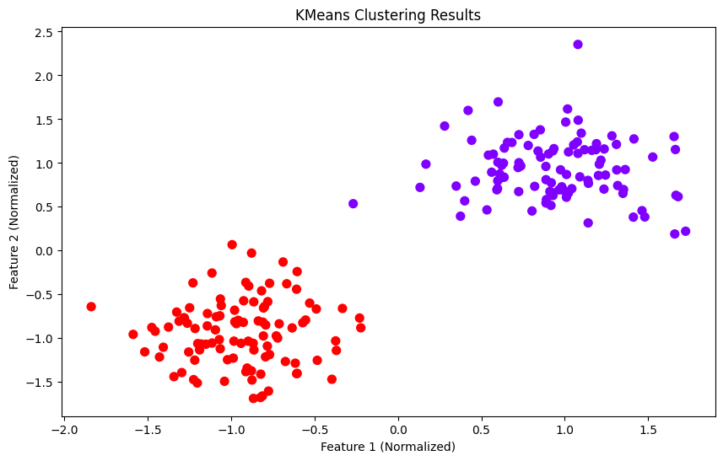

import numpy as np
import pandas as pd
import matplotlib.pyplot as plt
from sklearn.svm import SVC
from sklearn.model_selection import train_test_split

# Provided data for the "judgement" column
data = {
'judgement': [
"TRUE", "TRUE", "TRUE", "TRUE", "TRUE", "TRUE", "FALSE", "TRUE", "FALSE", "FALSE",
"TRUE", "TRUE", "FALSE", "FALSE", "FALSE", "TRUE", "TRUE", "TRUE", "TRUE", "FALSE",
"TRUE", "TRUE", "TRUE", "FALSE", "FALSE", "FALSE", "TRUE", "TRUE", "FALSE", "FALSE",
"FALSE", "FALSE", "TRUE", "FALSE", "FALSE", "FALSE", "FALSE", "TRUE", "TRUE", "TRUE",
"TRUE", "TRUE", "TRUE", "TRUE", "FALSE", "TRUE", "TRUE", "TRUE", "TRUE", "TRUE", "FALSE",
"TRUE", "FALSE", "FALSE", "TRUE", "TRUE", "TRUE", "TRUE", "FALSE", "FALSE", "TRUE",
"TRUE", "TRUE", "TRUE", "TRUE", "TRUE", "TRUE", "FALSE", "FALSE", "TRUE", "TRUE",
"TRUE", "TRUE", "FALSE", "TRUE", "FALSE", "TRUE", "TRUE", "FALSE", "TRUE", "TRUE",
"TRUE", "TRUE", "FALSE", "TRUE"
]
}

# Convert the 'judgement' column to a DataFrame
df = pd.DataFrame(data)

# Create a dummy feature for visualization purposes
df['dummy'] = np.arange(len(df))

# Split the data into features (X) and target (y)
X = df[['dummy']]
y = df['judgement']

# Split the data into training and testing sets
X_train, X_test, y_train, y_test = train_test_split(X, y, test_size=0.2, random_state=42)

# Initialize and train an SVM classifier with RBF kernel
svm_classifier = SVC(kernel='linear')
svm_classifier.fit(X_train, y_train)

# Generate a grid of points to plot
x_min, x_max = X_train['dummy'].min() - 1, X_train['dummy'].max() + 1
xx = np.linspace(x_min, x_max, 1000).reshape(-1, 1)

# Predict class labels for the grid points
predictions = svm_classifier.predict(xx)

# Visualize the SVM decision boundary
plt.figure(figsize=(10, 6))

# Plot the decision boundary and data points
plt.plot(xx, predictions, color='black', linewidth=2)
plt.scatter(X_train, y_train, c=y_train.map({'TRUE': 'blue', 'FALSE': 'red'}), s=50)

plt.xlabel('Dummy Value')
plt.ylabel('Judgement')
plt.title('SVM Decision Boundary with Linear Kernel')
plt.legend(handles=[plt.Line2D([0], [0], marker='o', color='w', markerfacecolor='blue', markersize=10, label='TRUE'),
plt.Line2D([0], [0], marker='o', color='w', markerfacecolor='red', markersize=10, label='FALSE')])
plt.show()

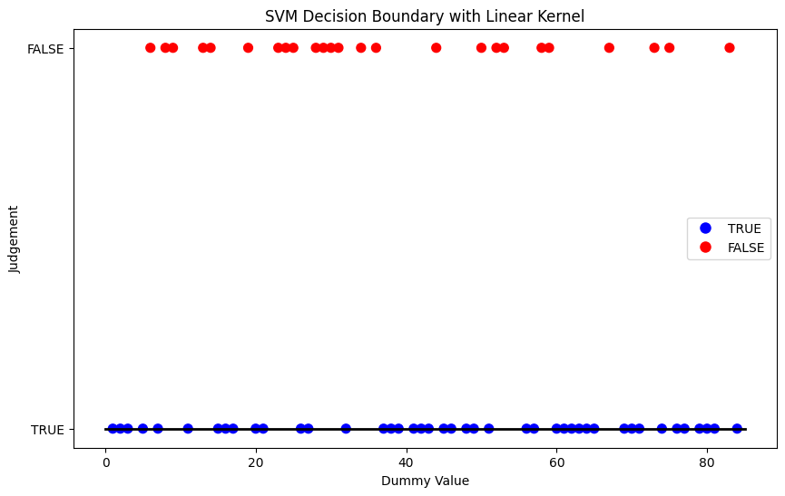

from google.colab import files
import pandas as pd
import numpy as np
import matplotlib.pyplot as plt
from sklearn.svm import SVC
from sklearn.preprocessing import LabelEncoder
from sklearn.model_selection import train_test_split
from matplotlib.colors import ListedColormap

# Upload the CSV file
uploaded = files.upload()

# Read the uploaded CSV file
file_name = list(uploaded.keys())[0]
df = pd.read_csv(file_name)

# Convert 'judgement' column to uppercase string type
df['judgement'] = df['judgement'].astype(str).str.upper()

# Filter rows where 'judgement' column is TRUE
filtered_df = df[df['judgement'] == 'TRUE']

# Encode the 'decision_type' column using LabelEncoder
label_encoder = LabelEncoder()
filtered_df['decision_type_encoded'] = label_encoder.fit_transform(filtered_df['decision_type'])

# Take the first 50 rows
filtered_df = filtered_df.head(50)

# Split the data into features (X) and target (y)
X = filtered_df[['majority_vote', 'age']]
y = filtered_df['decision_type_encoded']

# Split the data into training and testing sets
X_train, X_test, y_train, y_test = train_test_split(X, y, test_size=0.2, random_state=42)

# Initialize and train an SVM classifier
svm_classifier = SVC(kernel='linear')
svm_classifier.fit(X_train, y_train)

# Visualize the SVM decision boundary
plt.figure(figsize=(10, 6))

# Create a meshgrid of points for contour plot
x_min, x_max = X.iloc[:, 0].min() - 1, X.iloc[:, 0].max() + 1
y_min, y_max = X.iloc[:, 1].min() - 1, X.iloc[:, 1].max() + 1
xx, yy = np.meshgrid(np.arange(x_min, x_max, 0.01),
np.arange(y_min, y_max, 0.01))

# Predict the labels for the meshgrid points
Z = svm_classifier.predict(np.c_[xx.ravel(), yy.ravel()])
Z = Z.reshape(xx.shape)

# Plot the decision boundary and support vectors
cmap = ListedColormap(['#FFAAAA', '#AAFFAA', '#AAAAFF'])
plt.contourf(xx, yy, Z, cmap=cmap, alpha=0.8)

# Plot the data points
plt.scatter(X.iloc[:, 0], X.iloc[:, 1], c=y, cmap=cmap, edgecolors='k', s=20)
plt.xlabel('Majority Vote')
plt.ylabel('Age')
plt.title('SVM Decision Boundary')
plt.show()

